BRAC UNIVERSITY
Department of Computer Science & Engineering
Practice Problem sheet (Week5)
CSE 350: Digital Electronics and Pulse Technique

Question 1

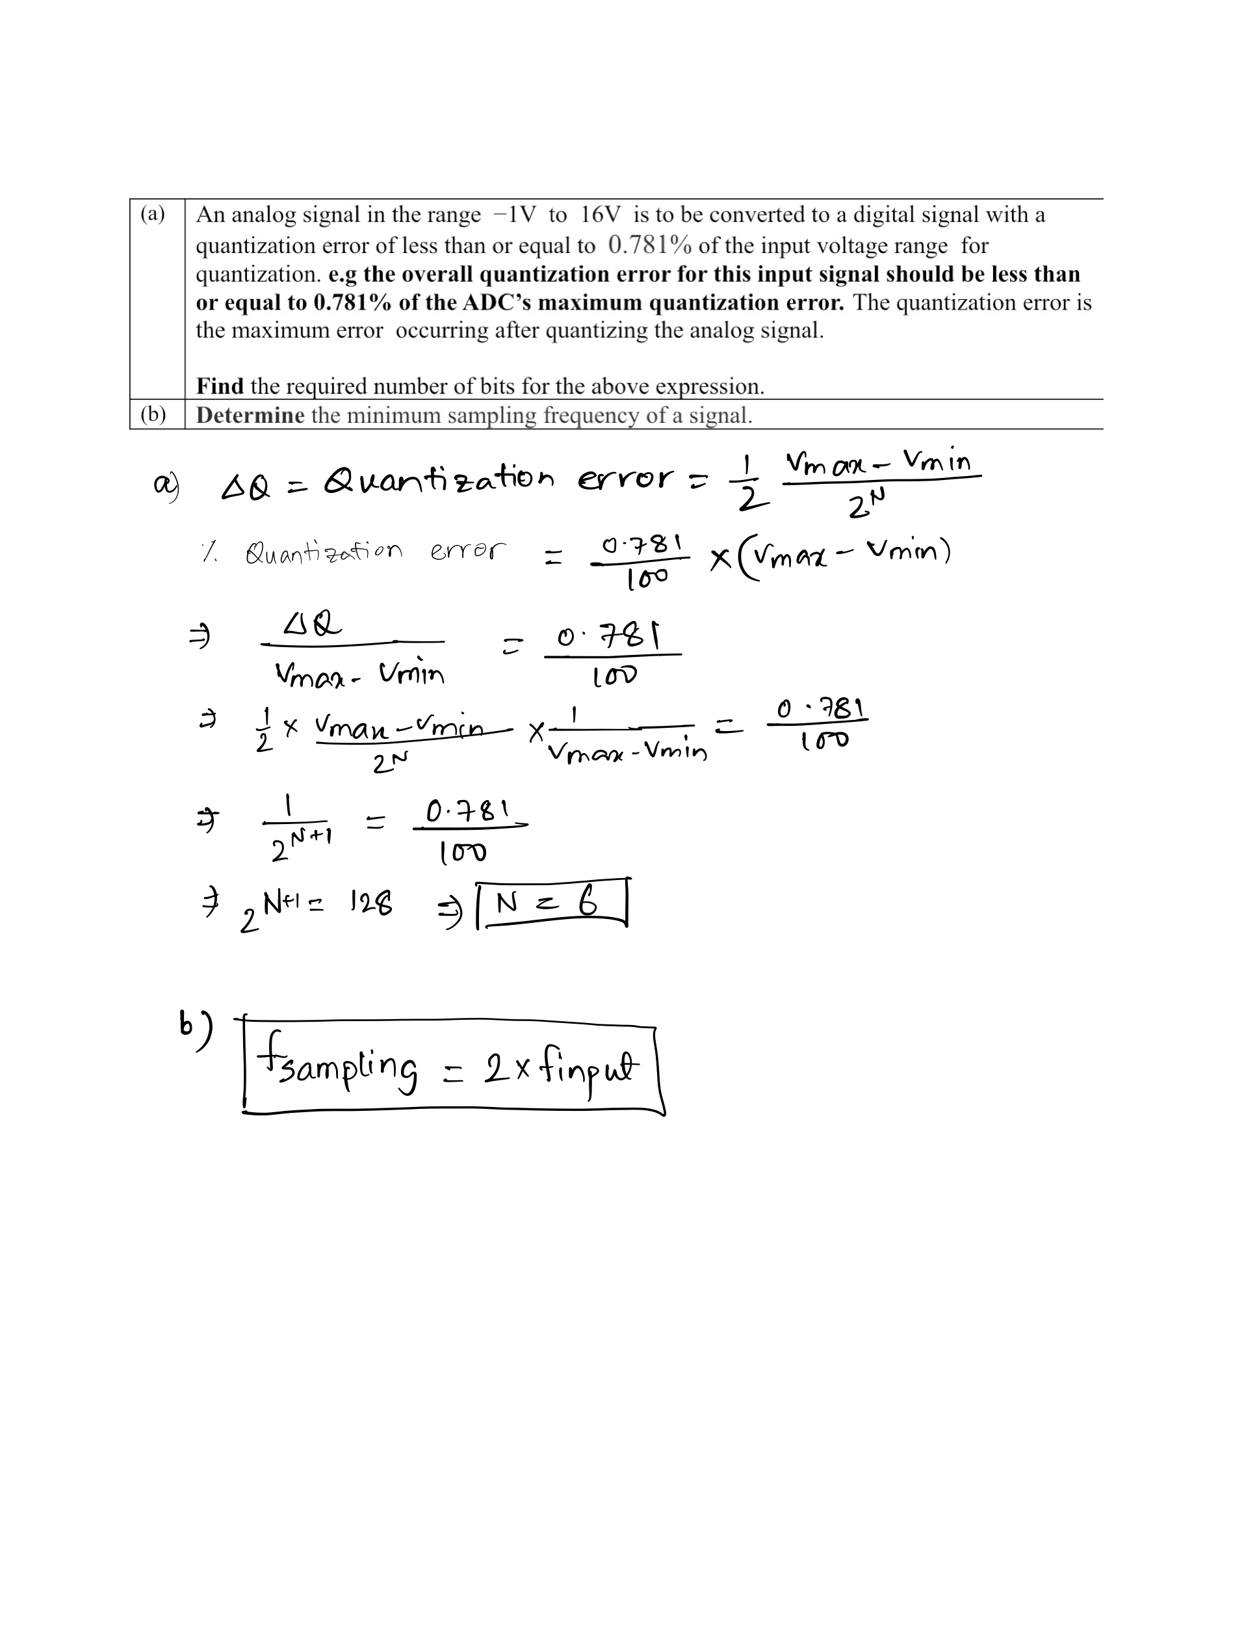

Question 2
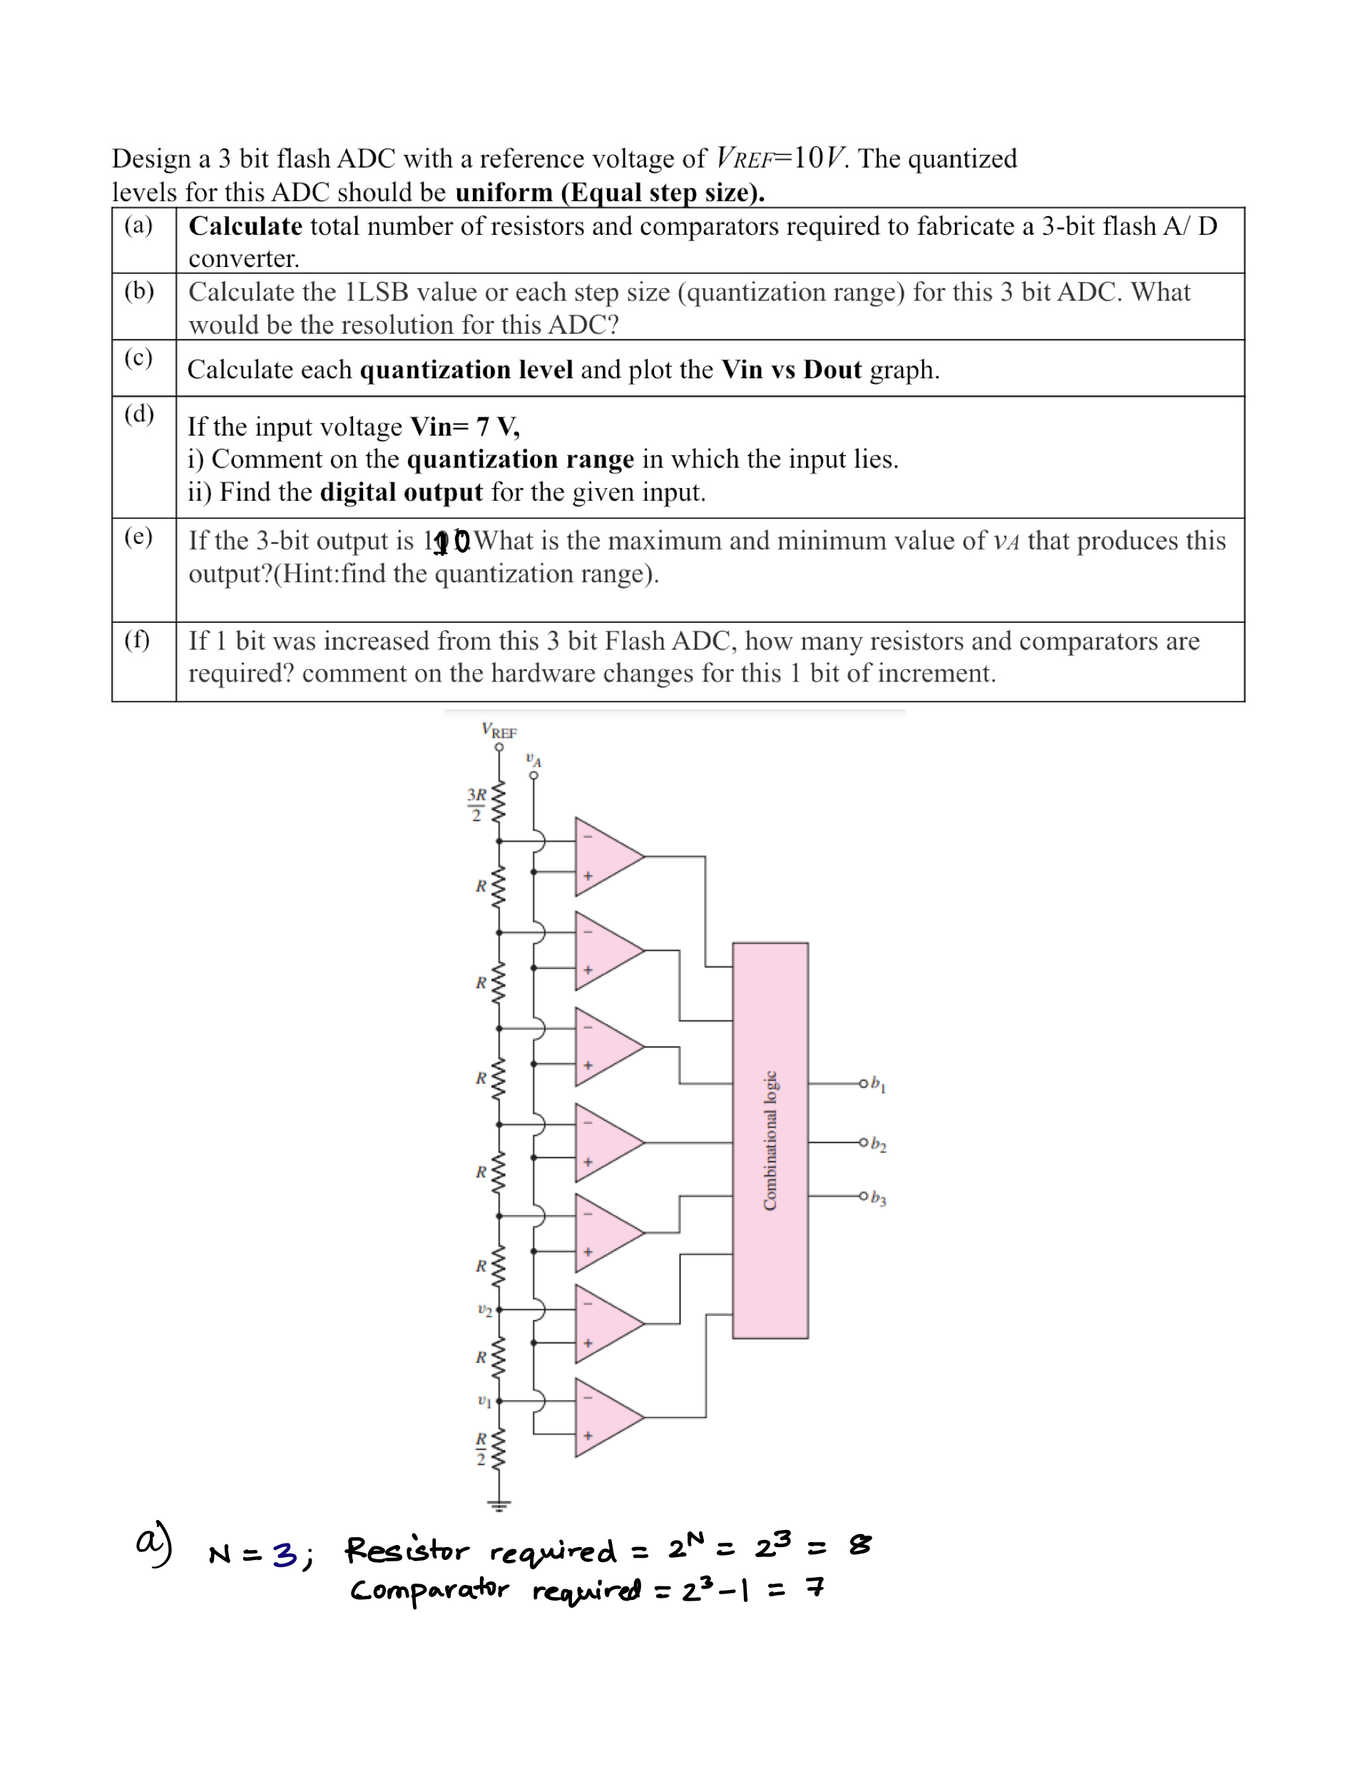
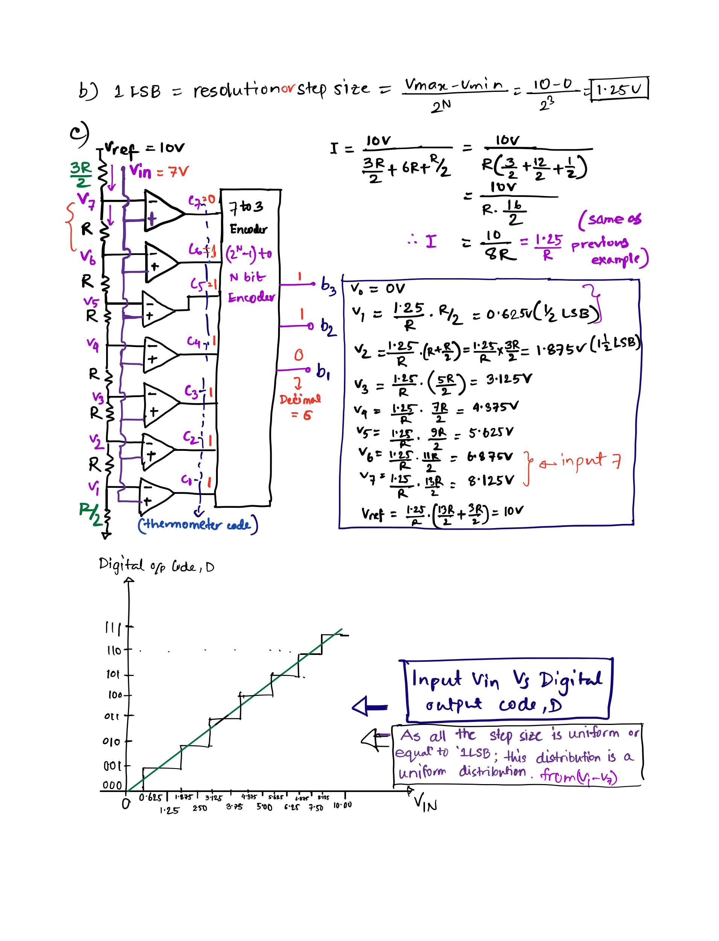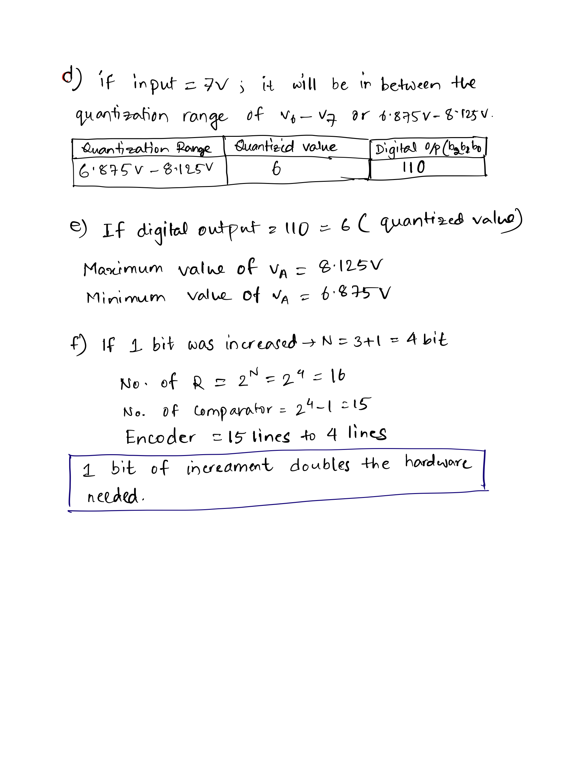

Question 3

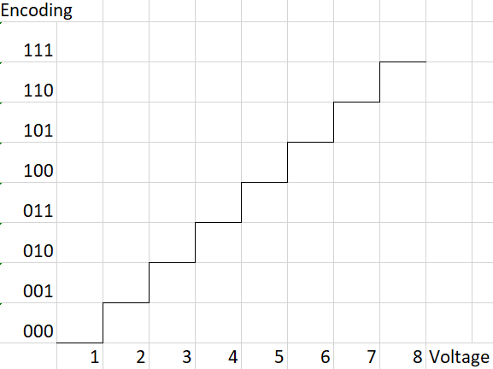
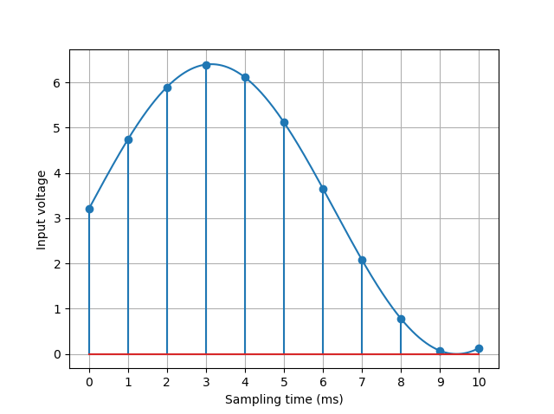
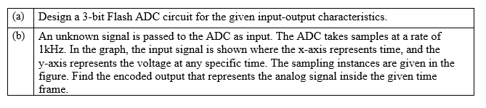

Solution:
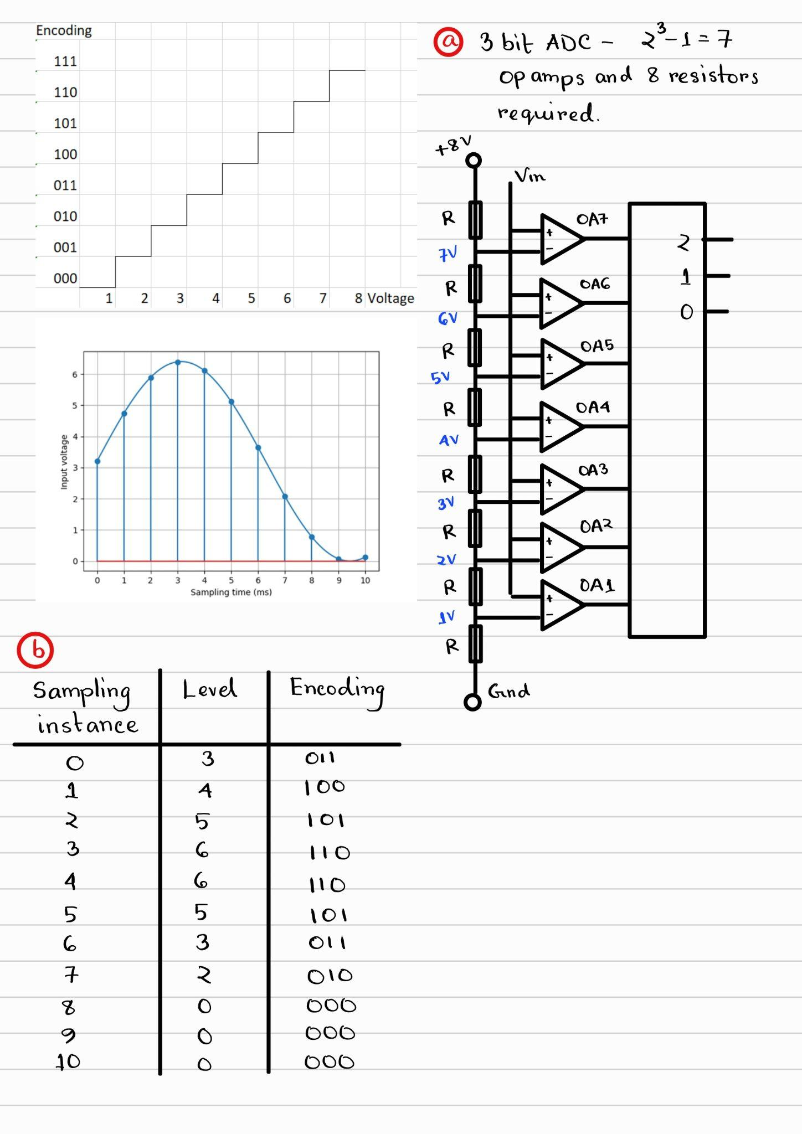

Question 4
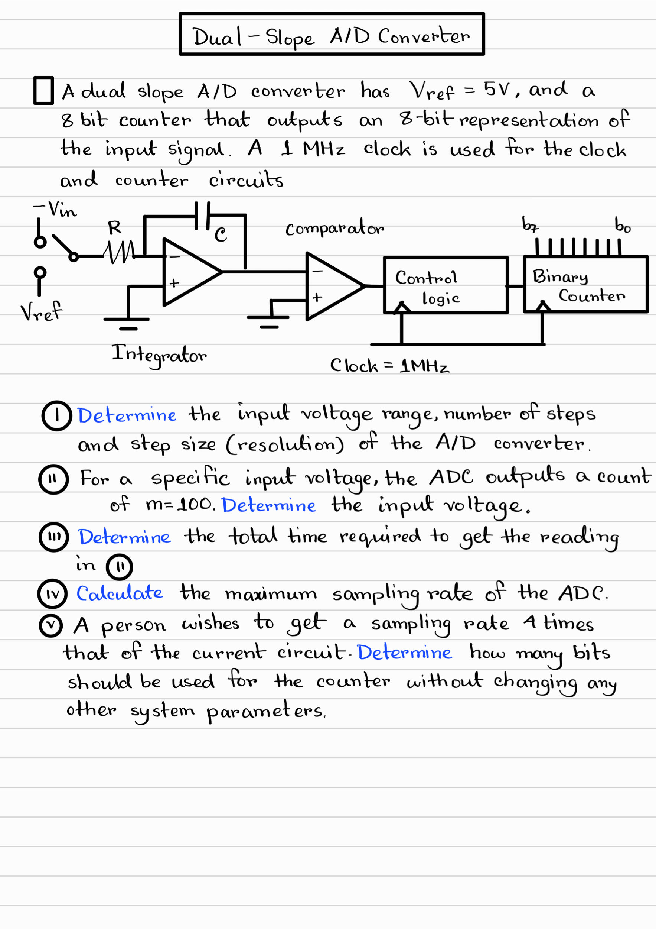
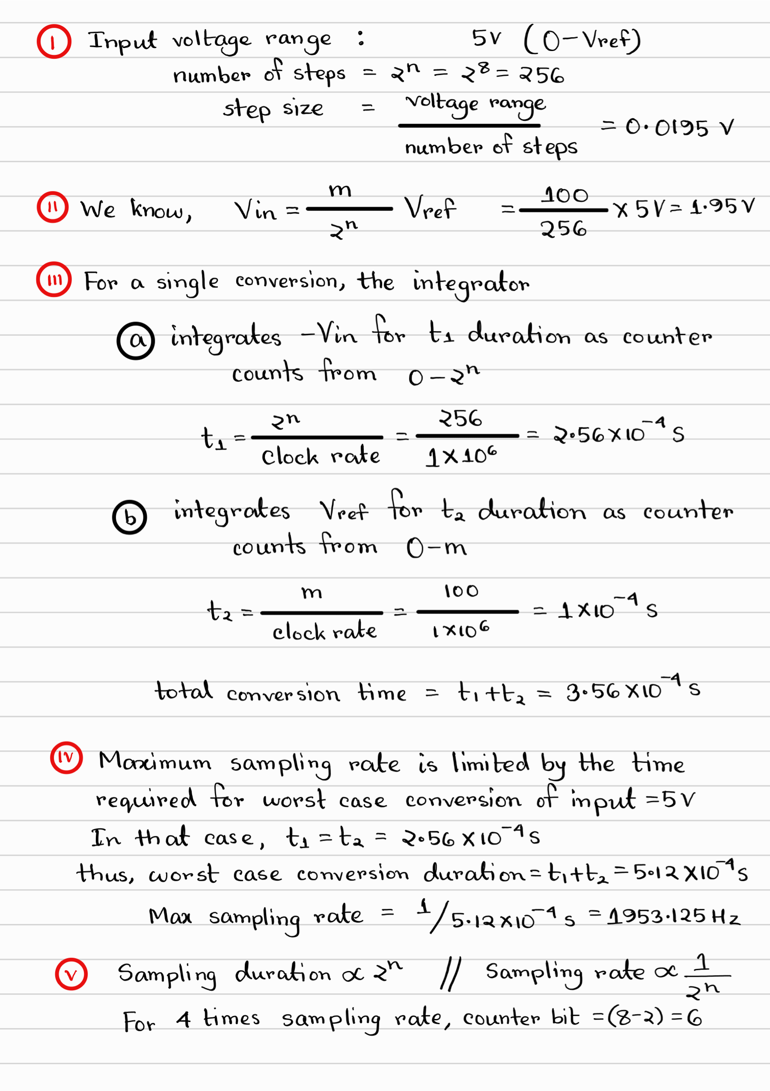
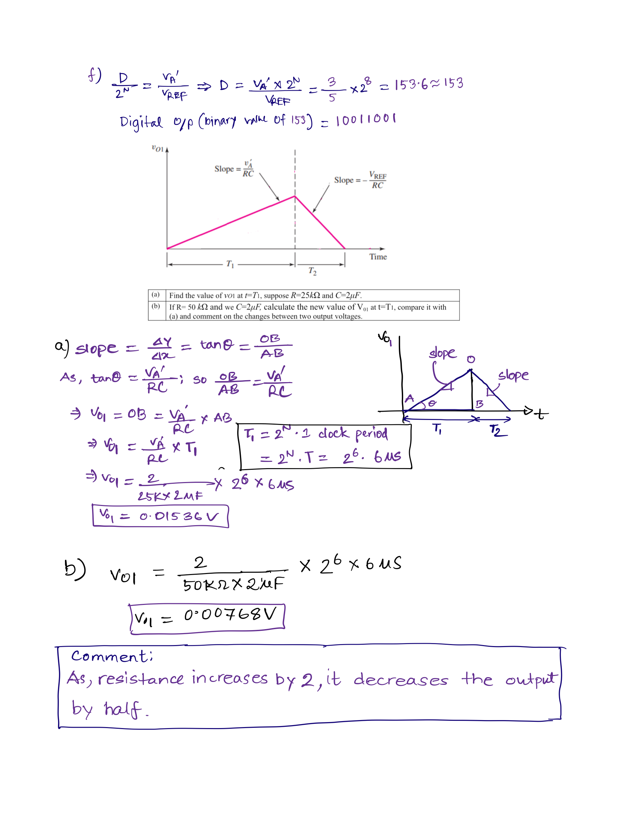

Question 5

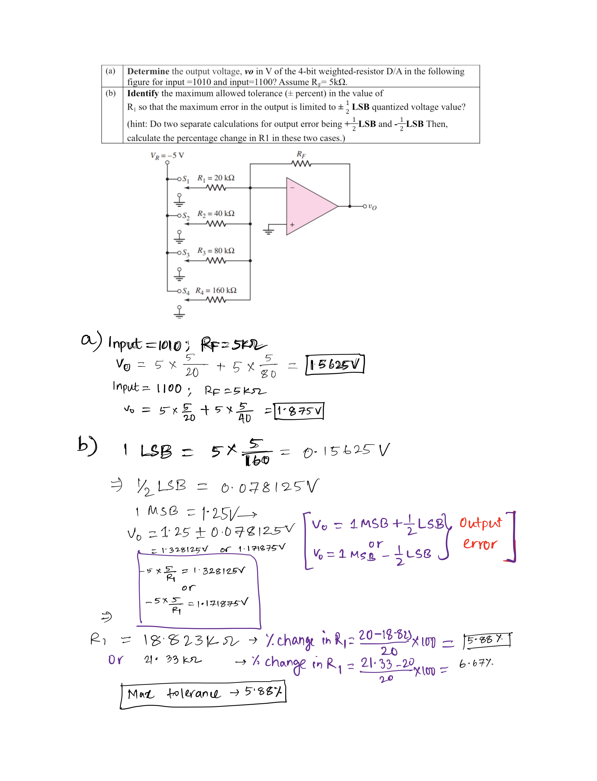

Question 6

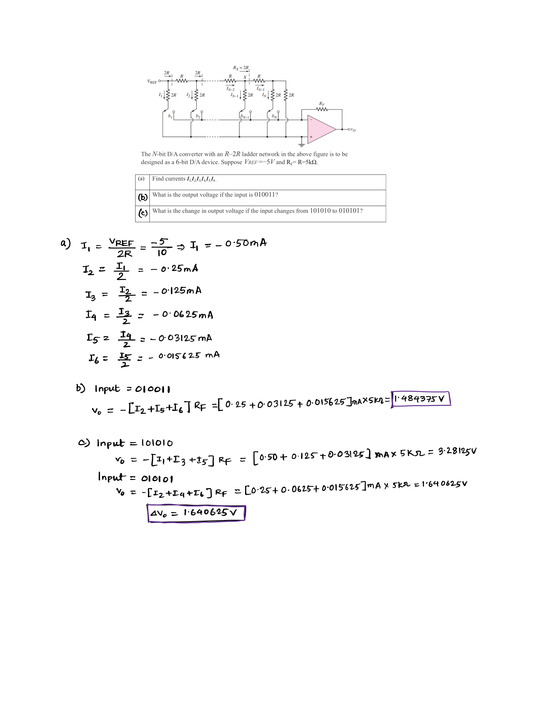

Question 7

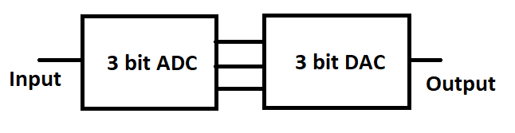

ADC Input Voltage | Encoding | DAC Output Voltage
0-1 | 000 | 0.5
1-2 | 001 | 1.5
2-3 | 010 | 2.5
3-4 | 011 | 3.5
4-5 | 100 | 4.5
5-6 | 101 | 5.5
6-7 | 110 | 6.5
7-8 | 111 | 7.5

(a) | For the following input waveshape, draw the reconstructed output by the DAC. The sampling instances are marked on the input waveshape.
(b) | Comment on the quality of the reconstructed signal and how the quality would be affected if additional bits were used for both the ADC and DAC.


Solution:
